Seizing Destiny: The Intelligent Community Playbook

http://www.mayorsandcities.com/opinions/viewpoint/seizing-destiny-the-intelligent-community-playbook-4
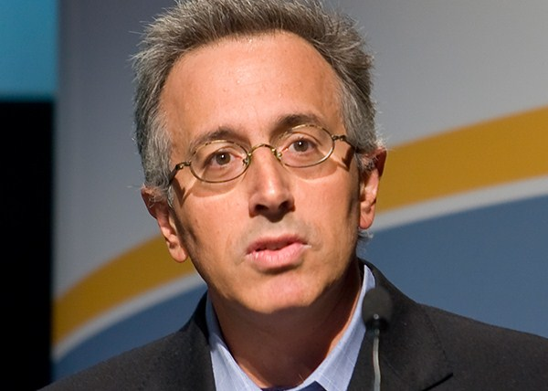
BY: Louis Zacharilla
POSTED ON: Jul 01, 2013

NEW YORK — New York is historically the place where if you think you have what it takes to become the best, you buy a ticket and you go to prove it. Whether it is modern dance at the Joyce Theater or basketball at Madison Square Garden, you will see in the audience a significant number of dancers and basketball players checking-out the best. Why? It is obvious. To be the best, you must emulate the best. Query the best. Challenge the best. That is the concept behind the Intelligent Community of the Year awards program and our think tank’s New York Summit, which took place June 5-7 in cooperation with New York University’s Polytechnic Institute.
We have designed an “anti-conference.” It takes into consideration the fact that being stuck for three days in an overly air-conditioned hotel, which ultimately becomes more echo chamber than learning experience, has seen its day. ICF ‘s Summit takes place in two boroughs and five different facilities. With regard to our goal, the re-energizing of cities and communities worldwide, the idea is to view communities as living organisms and track the causes of their success and failure.
The cornerstone of our international dialogue is the year’s Top7 Intelligent Communities. The cities’ mayors, tech leaders and others are invited to New York after a 10-month awards process to tell their stories. Through analysis of multiple sets of data by our global academic team and our research company in India, we go from 400 communities under observation and arrive at seven. They are the real “winners” and the stars of the New York show. They are given honors and a reception – and we put them under a microscope before an invited audience of 250 thought leaders.
They are examined in venues as diverse as 60 stories above Grand Central Station, the gritty urban campus of NYU’s engineering school and the Brooklyn Navy Yard, where Steiner Film Studios rolls out a literal red carpet for them to walk inside to the Intelligent Community of the Year Awards Ceremony. This year’s event was addressed by Blackberry founder Mike Lazaridis, who is helping to shape his Canadian community, Waterloo (2007 Intelligent Community of the Year), into the world’s Quantum Valley. He is spending CAN$250 million of his own money to make it so.
Taichung
Until we move from a silicon-based, “Broadband Economy” to a quantum future, which seems inevitable to those of us looking down the road, the rewards of job creation, social stability and cultural expression go to places that develop an increased, and increasingly sophisticated set of programs that enable collaboration and the mobilization of social capital. Emerging as the 2013 Intelligent Community of the Year was Taichung, Taiwan. Taichung, in only its second year as an entrant in the awards program, was selected for several reasons. The city of 2.7 million people has a balanced economy consisting of the world’s third greatest number of precision-machinery exports, and a rural economy that has added a layer of technology and innovation to become a significant contributor to local GDP. It does R&D on plant tissues, for example, to produce more diverse types of orchids for export as well as inventing disease-prevention formulas for plants.
Upon closer examination, Taichung is typical and an anomaly in several ways. Once known as the “Mechanical Kingdom,” an aggressive and charismatic Mayor, Dr. Jason Hu, has led the city since 2000. The Mayor and his team have reinforced the city’s leadership in precision machinery manufacturing and the production of semiconductors (Taiwan Semiconductor is headquartered there, and has committed to the development of a new $5 billion wafer facility.) It is home to 17 colleges and universities and seven major technology parks, just one of which generated 8,000 new jobs. The clustering effect is apparent. The backbone of the economy is made up of 1,500 small-to-midsize precision manufacturers, who share access to an enterprise resource planning system developed in collaboration with universities and the city. It offers capabilities that none can individually afford, which has sharply increased operating efficiencies which allows them to compete in a rough global industry.
However in many ways it still feels and is an industrial age city. Low-skilled jobs proliferate, while the city continues to add new levels of collaboration and intelligence to every industrial process. The leadership of Taichung envisions itself as a new type of Singapore, although it is not nearly as well known as that island-nation. It is fully committed to technology, but does not feel like a “techie town,” such as Austin, Texas, a former ICF Top7. It is doing things in a way that communities moving out of the industrial era can embrace.
Its forward thinkers are doing something few cities in this range have thus far been able to pull off, which is to become a cultural capital as well as an industrial powerhouse. When the director of Life of Pi, Ang Lee thanked Taichung in February, during his Academy Awards acceptance speech, Taichung realized the first part of a long-term plan to become a place that offers the “creative classes” a place to call home. Lee noted Taichung’s technical prowess in manufacturing ocean waves for his complicated special effects. Taichung had immediate bragging rights. On June 7, as it received the award as the world’s most Intelligent Community, it also reinforced a claim that it had been making: that is was prepared for the challenge of being a leader in the “community of communities.”

Louis Zacharilla, Co-Founder, Intelligent Community Forum
Mr. Zacharilla is credited with helping to launch the global intelligent community movement. He is a speaker at major events worldwide and the co-author of three books, including the recently published “Seizing Our Destiny.” In 2012, he represented ICF at the Nobel Peace Prize in Oslo,

