Taichung Visited by ICF from April 18-19 After Being Named One of the 'Top 7 Intelligent Communities of 2013': City Now in Contention for First Prize

Under the banner of 'The World's Taichung,' Taichung City has integrated itself with the global community, and thanks to the active approach it has taken to the creation of an 'intelligent city,' this year Taichung once more distinguished itself when it was selected as one of the 'Top 7 Intelligent Communities of 2013.' From April 18-19, Louis A. Zacharilla, one of the founders of the Intelligent Community Forum (ICF), made a 2-day visit to Taichung. In addition to sharing his views and experiences of promoting intelligent cities around the globe with members of various fields, he was also able to witness the results of Taichung's efforts to actively combine industrial, governmental and academic resources (covering areas such as broadband, the training of a 'knowledge workforce,' digital content, and advocating innovation and marketing) in the creation of an intelligent city.
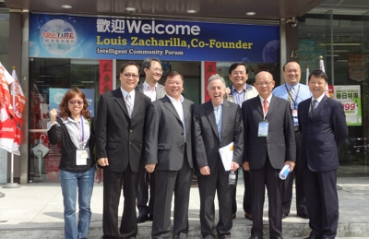
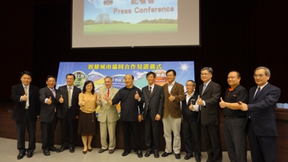
The recognition of Taichung City by an international organization such as the ICF and its selection as one of the 'Top 7 Intelligent Communities of 2013' is all down to the hard work of members of industry, government and academia, to whom the city is extremely grateful. This year the theme of the ICF has emphasized 'innovation and employment.' Taichung City is committed to the construction of a diverse digital infrastructure and improving the application of its ICT capability, as it actively creates a favorable investment environment. When it comes to industrial innovation, the city has used industry clusters to create a 'Central Taiwan Technology Corridor' in which members of an industry-academic alliance work together to cultivate new professional talent. This effectively meets the manpower requirements needed to upgrade industry, improving the quality of the labor force and providing abundant resources for advanced studies and education, consolidating and extending the competitive advantages of enhancing the workforce. In addition, smart technology from the Industrial Technology Research Institute (ITRI) has been co-opted to assist small and medium enterprises, providing guidance to precision machinery enterprises and tens of thousands of small and medium-sized component suppliers. This has elevated their technical standards and competitive advantages and introduced technology to traditional agriculture. International channels for the marketing of agricultural produce have been created and new industries have been created. At the same time, these have all helped to promote economic development.
During his visit on site, Mr. Zacharilla explained to the public about his objective in coming to Taichung City. In addition to finding out more about the city so that he could write a report for the ICF to assess whether or not to award the city first prize, Mr. Zacharilla also emphasized that, regardless of whether or not Taichung did win first prize, it had already proved itself to be an outstanding city: to distinguish itself from more than 400 other cities as one of the world's top 7 intelligent communities was no easy feat. He also said that the main aim of the trip was to learn about Taichung's experience in transforming itself into an intelligent city, knowledge that he would take back to the ICF and share with other cities.
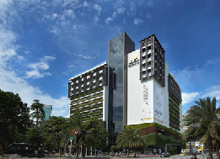
Mr. Zacharilla said that he was optimistic about Taichung's performance in various indicators used to assess whether or not a city qualified for first prize. Recycling, for example, is generally seen as a grubby and distasteful industry. Through its innovative approach, however, Taichung Dafeng Environmental Protection Co., Ltd has remodeled the work environment, work processes and R&D to create new value, transforming its image into one in which is it seen as a 'good neighbor.' Civil resources have also been integrated to reinvigorate abandoned buildings, creating the Calligraphy Greenway Chingmmei commercial district and transforming a rundown area into one that has surpassed its former glory. Based on a core concept of commitment to providing a healthier, more secure, pleasant and convenient living environment, ICT as well as integrated companies have been used to create Crystal House. In particular, the use of smart devices (such as smart phones and iPads), allows residents to understand and control their homes. The experience led Mr. Zacharilla to remark that nothing could be more suited to someone as lazy as him.
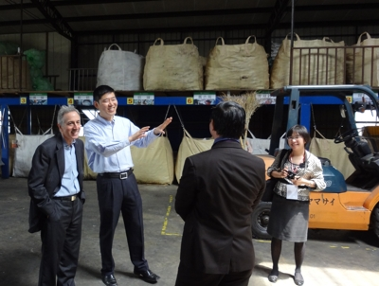
Whilst visiting the Tatu Technology Corridor, Mr. Zacharilla was briefed about the contribution of HIWIN Technologies Corp, Giant Manufacturing Co., Ltd., Taiwan Semiconductor Co., Ltd., the i236 Plan Office of the Industrial Technology Research Institute, the Central Taiwan Industry-University Alliance, the Taichung Government Economic Development Bureau and Department of Labor to transforming Taichung into an intelligent city. From this he learned how, thanks to the efforts of the Taichung government's Economic Development Bureau, the district had gradually achieved today's scale. In addition to attracting industries to base themselves in the area and gradually expand to become international, publicly-listed companies, it has also encouraged major companies to set up factories here. HIWIN, for example, is now the world's second-largest producer of ball screw linear rail industrial robots, and Giant has transformed itself from a contract manufacturer into a world-famous bicycle brand.
Mr. Zacharilla also asked representatives of the Taiwan Semiconductor Manufacturing Company (TMSC) why they had chosen to locate their factory in Taichung. Deputy Director Chen of TMSC was very clear about the company's motives for doing so: Taichung City is located in the center of Taiwan, and in addition to the city's geographic advantages, it also offers a number of convenient transport facilities - including an airport, port, high-speed railway, railway, as well as multiple highways. What's more, the assistance provided by the government's highly capable administrative team meant that TMSC's Taichung factory was able to be completed in just 3 years. These, said Deputy Director Chen, were the primary reasons behind TMSC's decision to set up a factory in Taichung.
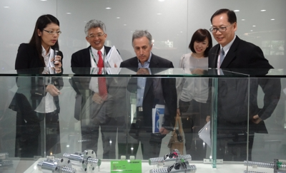
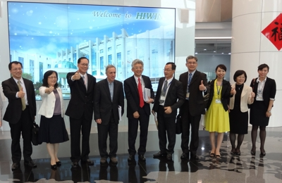
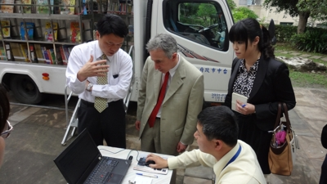
Mr. Zacharilla also traveled to a remote area of the city, where he learned about the Digital Opportunity Center. The center was set up to help disadvantaged members of the community and provides more ways of learning through digital mediums. In 2011 it released the 'e-schoolbag' (a mobile learning tool), which was incorporated into the Experimental Education Plan. In addition to providing an adaptive learning platform for students that freed them from time constraints, the initiative has also enhanced the ICT capability of schools. Furthermore, through the ITRI the Industrial Development Bureau of the Ministry of Economic affairs integrated the resources of the 'Intelligent Life and Technology Application Project' to provide guidance in promoting a large-scale e-book cloud service. It used 'cloud libraries' to allow members of remote communities to read books in a digital format. The National Public Information Library Services was used to connect municipal libraries in 5 cities and 17 counties across Taiwan, allowing mobile reading vans to bring the joy of digital learning to the students in remote primary schools. The Taichung Department of Culture Affairs also uses mobile libraries which, at the same time and location each week, deliver books – including books that members of the public have reserved online – to school districts suffering from a lack of resources. Mr. Zacharilla also personally experienced Taichung's 'Reading Access' service aimed at shortening the gap between urban and rural areas. In addition to being a departure from standard libraries that only serve local readers, this service also allows libraries to make the most of their resources.
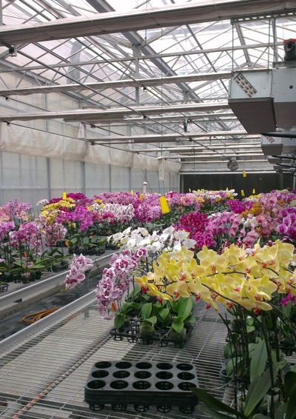
With regard to developing innovative technology in Taichung's agriculture, in addition to boosting agricultural competitiveness, the industry is also undergoing a transformation towards 'refined agriculture' (agriculture that combines traditional techniques and new technology) and leisure agriculture. The Agricultural Research Institute has successfully developed a digital monitoring system for the production environment of fruit and vegetable facilities that reduces the manpower required to manage greenhouses and achieves the objective of real-time monitoring. Using a touchscreen deployed within the greenhouse, or a remote computer, smart phone or tablet, it is possible to connect to a webcam to observe a real-time image of the greenhouse. Furthermore, through automatic control equipment and automatic scheduling, it is also possible to adjust the temperature, humidity and lighting of the greenhouse – successfully increasing production efficiency and improving the quality of produce.

Furthermore, the founder of Green Culture Co., Ltd. Stood by his father's extensive experience in floriculture and the art of breeding varieties, achieving the close integration of traditional agriculture and modern biotechnology. He has independently researched and innovated a new lightweight container, and has also independently developed an information management system that effectively and accurately controls each stage of production. This has promoted highly automated production processes and greatly improved the production efficiency of orchid seedlings, demonstrating the commercial management of Taiwan's orchid industry and the precise level of industrial production. The supply of seedlings has been linked up to market demand, and successful penetration and expansion of the international market has been achieved. Within China, the company has worked with members of industry, government and academia to continually perfect this technology and cultivate the highest-quality flower varieties, expanding export markets.
In addition, at a press conference during his visit Mr. Zhacharilla also shared his impression of Taichung. He said that Taichung wasn't being 'led by the nose' by technology; rather, it was really applying technological 'innovation,' to create more success. He had also been very impressed by Taichung's efforts in the field of health, particularly its initiative of going without meat one day a weak – this was a wonderful idea, and, because Italy shared a similar culture and tradition, he had been deeply touched by it.
Mr. Zacharilla also said that, in addition to Taichung's application of scientific and technological innovations, what was more important was that people threw themselves into the 'culture' associated with this. The 'cultural capital' created by Taichung has enhanced the economic momentum of the entire society. Mayor Hu, he said, was a great mayor with tremendous vision because he understood that what's most important for a great city is having 'cultural assets.'
Mr. Zacharilla also said that he had witnessed the cultural vision of Taichung City, and the city was on the verge of entering a new renaissance of literature and the arts, using its knowledge of innovation and technology to once again bring into play its original cultural assets. He also said that, compared to other cities, Taichung's 'warmth and hospitality' was one of its greatest advantages. The welcome he had received at Taichung made him feel as if he'd returned home; Italy, he said, has a saying: No where's better than home. In his eyes, 'Taichung City has already won,' because he felt that nowhere was better than Taichung City.
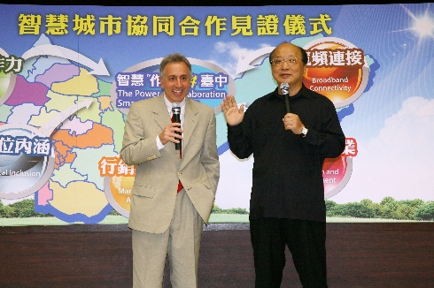
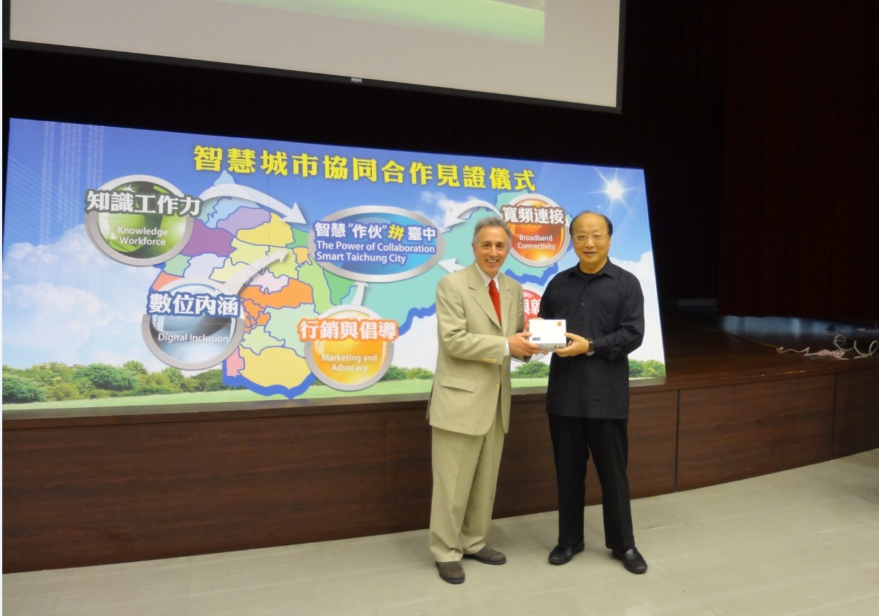
We would like to thank members of industry, government and academia for the assistance they provided during the visit; for the ICF, they were the manifestation of Taichung's achievements in promoting its transformation into an intelligent city. We would also like to thank Mr. Zacharilla for the suggestions he provided during conversations with him. The Taichung City Government will learn from its experience and continue to strengthen cooperation with members of industry, government and academia in promoting new construction or initiatives, creating a more prosperous economy in Taiwan and a happier living environment for residents of the city.

